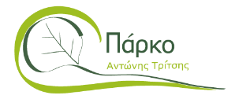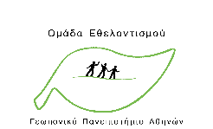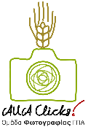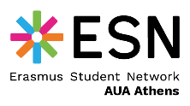

Hellenic Republic
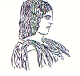

The Agricultural University of Athens,
The International and Public Relations Office,
Address: 75 Iera Odos Str.,
Gr- 11855, Athens, Greece,
Information: Rania Hindiridou
Tel. No.: (+30) 210 5294841
E- mail: public.relations@aua.gr
Athens, Tuesday, November 28 2023
PRESS RELEASE
Participation of the Agricultural University of Athens in the global CNN Invitation – Call to Earth Day.
The Agricultural University of Athens along with the European University for Smart Urban Coastal Sustainability EU-CONEXUS, is taking part in the worldwide Call Invitation - Call to Earth Day for the third consecutive year. Today, on Tuesday, November 28 2023, the annual Call, entitled "Call to Earth" is an initiative of the multinational cable and satellite information television network CNN, in cooperation with the Swiss watch designer and manufacturer Company ROLEX, with a view to the enhancement of awareness, action and education about fundamental environmental issues. The particular action represents a considerable commitment undertaken by CNN to present the environmental challenges faced by the planet, in combination with proposed solutions.
Under the framework of the invitation, groups from around the world are invited to implement an action pertaining to the society awareness towards the protection of the environment. Throughout the day of invitation, the actions performed shall be featured on all the communication channels of CNN. In response to the practical action – answer to the particular invitation, in the course of November, the nine (9) Universities - Partners of EU-CONEXUS have organised a range of environmental activities.
Specifically, the Agricultural University of Athens (AUA), being a member of EU-CONEXUS, in collaboration with the AUA Volunteering Team, the Photography Team - AUA Clicks!, together with the Erasmus Student Network of the Agricultural University of Athens - ESN AUA Athens, have organised a Cleaning Action in the Environmental and Educational Awareness and Development of the Social Economy Metropolitan Park, called “Antonis Tritsis”.
More than 30 students of the Agricultural University of Athens, along with members of the staff of EU-CONEXUS have offered voluntary work regarding the cleanliness of the park, which is spatially specified in the Western Metropolitan Athens, thus constituting the largest Metropolitan Park in the Attica Basin, of a total area extending approximately to 1,200 acres. The particular park is a popular destination for the inhabitants of Athens, with an average of 15.000-16.000 visitors at the weekends and even more on public holidays, or at major events. The President of the Metropolitan Park “Antonis Tritsis”, Ms. Sophie Mavrikou, Assistant Professor of the Department of Biotechnology of AUA has participated in that action, too. This collective effort has led to the collection of waste. The action mentioned above is a striking example of the offer and aid provided by the voluntary activities, carried out by a small group of motivated and concerned people to the creation of cleaner and more sustainable areas, besides the strengthening of the ties amongst the members of the EU-CONEXUS Community.
It is worth mentioning that all the participants have done their best. In particular, the Communication Manager of EU-CONEXUS, Ms. Foteini Paradeisi, the representative of the EU-CONEXUS Student Board, Ms. Myrsini Stagaki, the Student Ambassadors of EU-CONEXUS, namely Ms. Eleftheria Garoufali and Ms. Ourania Kisti, the members of the AUA Volunteering Team, Ms. Christina Kanaki, Ms. Marina Petridi and Ms. Alexandra Hatzigianni, the members of the AUA Clicks! Photography Team, Ms. Ioanna Hamilaki, Mr. Alexandros Botsolos, and Mr. Petros Oikonomou, as well as the ESN AUA Athens volunteers, Ms. Foteini Tsakardanou and Mr. Foivos Drosos Anagnostopoulos, they have all contributed actively, either by their physical presence, or by distance to the creation, promotion and implementation of the specific action.

