Hellenic Republic

The Agricultural University of Athens,
The International and Public Relations Office,
Address: 75 Iera Odos Str, GR-118 55, Athens, Greece
Information: Rania Hindiridou,
Tel.: (+30) 210 5294841,
e-mail: public.relations@aua.gr

Athens, March 28 2022

PRESS RELEASE

Α Monument of Nature set at the verdant land area of the Agricultural University of Athens
A more than Five Centuries-Old Olive Tree was transplanted at the pertinent green space created in the Agricultural University of Athens on Monday, the 21st of February 2022, emerging as a Natural Monument.
Indeed, that centuries-old olive tree has been uprooted by the Municipality of Aigialeia, in particular by the village of Camares in the town of Aigio, wherein the railway network of the Hellenic Railways Organization (OSE) is being expanded, in addition to finding a hospitable environment on the green territory of the Agricultural University of Athens, opposite the Roussopoulos Building, on the north side of the Campus.
Furthermore, the specific action falls into the framework of the Corporate Social Responsibility of the Hellenic Railways Organization created within OSE in order to facilitate infrastructure projects, namely ERGOSE S.A., whereas it also forms, an innovative environmental program, which is being funded by the Green Fund, with the aim of rescuing olive trees within the expropriated areas required for the construction of new railway projects.
It is actually the first time that such an action has been developing in our country, with the intention of managing plant capital of olive trees, through their rescue by means of their transport and transplantation in collaboration with public-sector bodies.
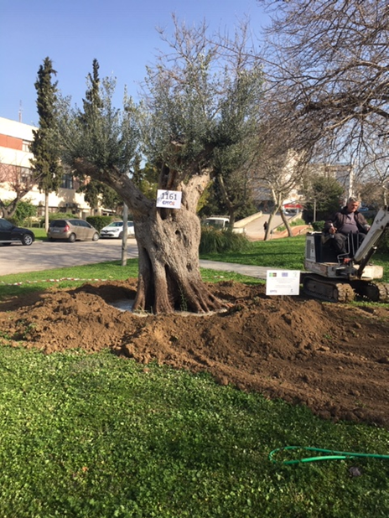
Besides, it is noteworthy that the transport and transplantation process of undertaking of that Olive Tree has been coordinated by the Vice Rector for Finance, Programming and Development, Professor Iordanis Chatzipavlidis on the part of the Agricultural Univeristy of Athens, along with the Directorate of Technical Services and the Environmental Management Office of the Institution.
In conclusion, the Agricultural University of Athens expresses its warm thanks to both the ERGOSE administration for its contribution to the achievement and completion of the project and the Green Fund for the distribution of the particular olive tree free of charge, including its transport as well, since it hereinafter constitutes a local landmark at the flourishing land area of the Agricultural University of Athens.

