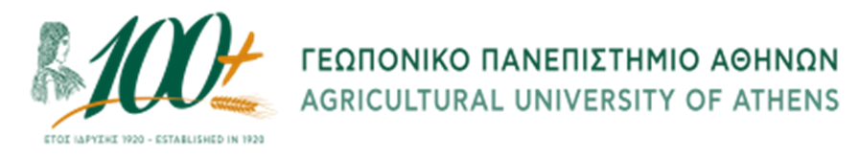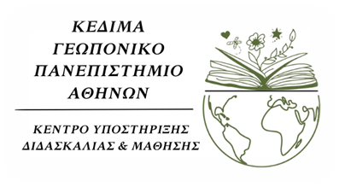

Hellenic Republic
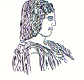

The Agricultural University of Athens,

The International and Public Relations Office,

Address: 75 Iera Odos Str., Gr- 11855, Athens, Greece,

Information: Rania Hindiridou

Tel. No.: (+30) 210 5294841

E- mail: public.relations@aua.gr
Athens, June 23 2023

PRESS RELEASE

The 1st Conference of the Centre for Teaching and Learning (CTL- KEDIMA) was held at the Agricultural University of Athens.

On Monday, June 12 2023, the Centre for Teaching and Learning (CTL- KEDIMA) of the Agricultural University of Athens, organised with success the first Conference – Info Day, entitled: “UNIVERSITY TEACHING AND PERCEPTIONS OF FACULTY STAFF FOR TEACHING WORK: Good practices and training methods in life and earth sciences” . The Information Day took place at the Conference Room of the Library of the Agricultural University of Athens with physical presence and online by means of live streaming.
The current action is implemented within the framework of the Sub-project (01): “Support Office for Teaching and Learning at AUA” of the Action: “Support Office for Teaching and Learning at AUA” with Project Code: (MIS) 5165176/ Special Account for Research Funds - ELKE 123.0001, being under the framework of the Operational Programme: “Human Resources Development, Education and Lifelong Learning 2014-2020”, co-financed by the European Social Fund (ESF).

Ms. Zoe Gavriilidou, Ms. Aikaterini Kedraka, Ms. Maria Drosinou – Korea, Mr. Nikolaos Dercas, Ms. Krista Baka, as keynote speakers of the Conference have analysed in detail, issues of University Teaching, approaching the notions of Teaching and Learning, with strong focus on the final beneficiary of the educational process and references to terms, such as “emerging adulthood”, “diversification in teaching” setting up the conceptual framework of the demands and challenges faced by the faculty staff of Higher Education.
The Vice Rector for Academic and Administrative Affairs, Lifelong Learning and Extroversion, Mr. Emmanouil Flemetakis, Professor, has opened the Conference, highlighting that the establishment of the Structure of Teaching and Learning Centers is an ideal springboard for the accomplishment of optimization of the university studies level, inasmuch the prevention of undesirable phenomena, which stand as an impediment to higher education studies, thus leading to either extended studies, or to a lack of completion of the studies required. Furthermore, the Vice Rector, Mr. Emmanouil Flemetakis has featured the targets and the forthcoming actions of CTL- KEDIMA at the Agricultural University of Athens, focusing on the attempt made in an orderly way, by the Academic Community as a whole for providing quality education with high standards. Besides, he has laid emphasis on the significance of utilising pedagogical methods and incorporating technological tools, with a view to achieving the best learning outcomes, skills building and equal access to learning with the aim of improving the Study Programs and reshaping the social role of the University, too. Concluding his speech, he has concentrated on the fact that the Agricultural University of Athens coordinates the Actions and Measures, taken by the Centre for Teaching and Learning, with standards in accordance with common practices of the Horizontal Action of the CTL- KEDIMA in Greek Universities, in the interests of creating incentives and opportunities that shall lead to the well-being and professional development of the educator – Professor, ensuring also in that manner, academic freedom in teaching and research.
Afterwards, the Scientific Coordinator of the Programme: “Horizontal Action of Support Offices for Teaching and Learning at HEIs”, Ms. Zoe Gavriilidou, Professor of Democritus University of Thrace, has mentioned the role and goal of CTL- KEDIMAs at Greek HEIs. Following the above statement, the Coordinator and Scientific Director of KEDIMA of Democritus University of Thrace, Ms. Aikaterini Kedraka, Associate Professor, has elaborated a discussion about the importance of University Teaching over Higher Education. Indeed, Ms. Kedraka by means of her speech, has shed light on the multiple dimensions and aspects of contemporary university teaching, stressing the necessity to modernize teaching methods with new pedagogical approaches based on international standards.
Next, Mr. Nikolaos Dercas, Professor of the Agricultural University of Athens has presented the actions implemented by the Agricultural University within the framework of the project Student Social Welfare Support Interventions, highlighting that the foundations have been laid for equal access and inclusion, through structures staffed by qualified scientific personnel. Thereafter, the floor was taken by Ms. Maria Drosinou – Korea, Assistant Professor of the University of Peloponnese, noting the considerable integration of cooperative teaching into higher education, along with that of individualised learning. At the final stage of the discussion, Ms. Krista Baka, Psychologist – Psychotherapist, has talked about the contribution of good practices into higher education, underlying the support framework of the educator upon all the aid measures of the Agricultural University.
A large number of academic, administrative staff, as well as a lot of associates of the Agricultural University of Athens, inasmuch those coming from other Higher Education Institutions have attended the Conference with physical presence and by online process. Throughout the Info-Day, specifically after the broad range of the suggestions and contributions made, concerns have been raised in an open discussion pertaining to the following perspectives, such as Courses of Study as a key pillar for education of the teaching staff, besides the other actions of KEDIMA performed at AUA, the ways of using new technologies in teaching, the conditions that shall assist further development of KEDIMAs, in addition to the upgrade of the teaching work, the professional advancement of the educator and the undivided evolution of the research work.

