Hellenic Republic

The Agricultural University of Athens,
The International and Public Relations Office,
Address: 75 Iera Odos Str. GR-118 55, Athens, Greece
Information: Rania Hindiridou,
Tel.: (+30) 210 5294841,
e-mail: public.relations@aua.gr
Athens, October 3 2022

PRESS RELEASE

Presentation of the Agricultural University of Athens before the Special Permanent Committee on Research and Technology of the Hellenic Parliament

On Wednesday, September 28 2022, the Special Permanent Committee on Research and Technology of the Hellenic Parliament met upon ”Innovative diagnostic technologies in Life Sciences”. The Rector of the Agricultural University of Athens, Mr Spyridon Kintzios, Professor, being the keynote speaker invited, elaborated in depth the particularly intense activity of the Public University into Life Biosciences, highlighting the necessity for more financial institutions, willing to invest in the transfer of biotechnological research results in practical application and the market area, as well as the utilization of more specialized consultants in the field of biotechnology patents, inasmuch international certifications.
Indeed, the Rector of the Agricultural University of Athens has presented as a recent example not only of this procedure, but also of the opportunities created by global challenges, the innovative and highly sensitive biosensor system developed in cooperation with the Assistant Professor Sophie Mavrikou and the research team of the Laboratory of Cell Technology, which detects the S1 spike protein, of the Corona Virus SARS-CoV-2 in just three minutes, without the need for previous processing of the sample, while at the same time, there is the possibility of antibody test conversion, with a view to checking immunization against the Covid 19 disease.
In conclusion, the Rector, Mr Kintzios, referred to the pilot and first in the world annals programme of the nationwide digital collection of epidemiological data about respiratory viruses, by means of the use of advanced portable diagnostic devices, in collaboration with a well-known pharmacy chain and large public hospitals in Athens. The Ultimate goal is the provision of this integrated system at the disposal of the State, while its successful pilot operation shall place Greece high on the map of the digital transformation of economy, constituting an exportable value, too.

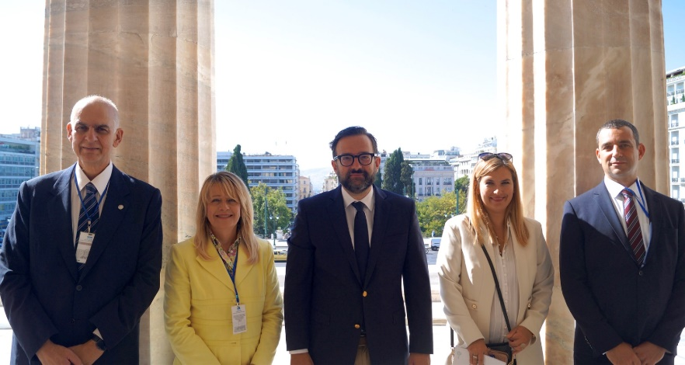

Photo. From left to right Spyridon Kintzios (Rector of the Agricultural University of Athens), Ioanna Koukli (President of Hellenic BioCluster), Christos Tarantilis (Member of the Parliament, Chairperson of the Hellenic Permanent Parliament's Committee on Research and Technology), Sophie Mavrikou (Assistant Professor AUA), Sergios Katsaros (Head of Commercial & Investor Relations of the Start-up company BIOPIX-T).

