Athens, 15/09/2021

The Library & Information Center “Alexandros Poulovasilis”, of the Agricultural University of Athens, in collaboration with the Greek Ministry of Education and Religious Affairs and the European Social Fund, runs a Program (under the M.I.S. Code: 5045556), about the accessibility of our students with learning difficulties and disabilities.
Within the framework of this Program, our Library cooperates with Accessible Multi-modal Electronic Library (AMELib). Indeed, we provide for our students with special educational and different needs, the possibility to choose a book from our catalogue, converting it to an accessible file, customized for their particular educational needs.
Therefore, we are proud to announce, that we have completed the conversion of one (1) more book from our catalogue, described, as follows:
✓ “Special Agriculture - Grain and Legumes”, 2nd Edition, by Despoina Papakosta-Tasopoulou, published by “Sychroni Paideia Publications” in 2012
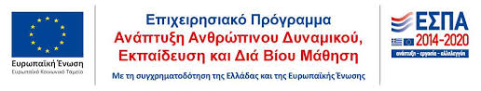
These books are available, in the platform of AMELib (use by personal login account). In addition, there are more books to be converted, as soon as possible. We would, also, like to thank the publishers of those books, for their support to our project.

