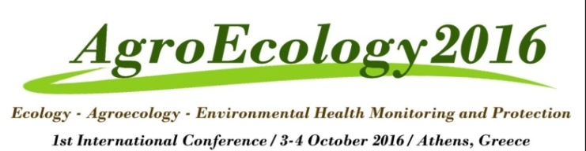

Invitation
The Laboratory of Ecology and Environmental Sciences of the Agricultural Universtity of Athens organizes the 1st International Conference on:
“Ecology - Agroecology - Environmental Health Monitoring and Protection” (“AgroEcology-2016”)
The Conference will be held on 3rd and 4th of October 2016, from 9:00 to 17:00, at the Multipurpose Hall on the second floor of the Central Administration building at the premises of the Agricultural University of Athens.

The Conference’s language is English

Members of the Scientific and Student Society are invited to participate free of charge.

Students who participate will be given a Certificate of Attendance

